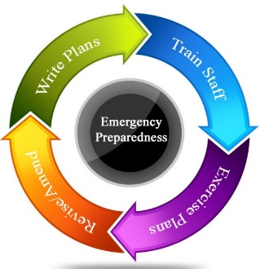

Booking Form

Safety First Emergency Preparedness Training Session

Thank you for your interest/enquiry in respect of the above training session.
Please fill out the form below and return via email to the following address: training@safetyfirst.co.nz . Our Trainer/Co-ordinator Anne Brown will contact you to confirm your booking.

Name of Company and Contact person for invoicing *

Email address*

Contact Phone Number/s *

Full Day Session (20/10/16) * Number of attendees *

Name/s of attendees *

Purchase Order / Work Order Number *

Please read the attached Cancellation Policy and tick the box below to confirm you have read and accept these conditions. Invoices will be sent out upon completion of the courses.
(Kindly provide your Company PO Box details and to whom the invoice should be addressed to)

Cancellation rates

Once the works have been agreed, Safety First operate the following cancellation policy:

Timescales Cancellation Rate
Between 10 - 20 days before the commencement date. | Nil
Between 5 – 10 days before the commencement date. | 50% of the agreed price to be paid.
Between 1 - 4 days before the commencement date. | 75% of the agreed price to be paid.
On the day | 100% of the agreed price to be paid.

Should Safety First need to cancel the work, then no costs will be charged to you.

