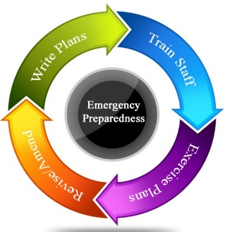

**Booking Form**

**Emergency Preparedness Training Session**

**Thank you for your interest/enquiry in respect of the above training session.**

**Please fill out the form below and return via email to the following address:** [**training@safetyfirst.co.nz**](mailto:training@safetyfirst.co.nz) **. Our Trainer/Co-ordinator Anne Brown will contact you to confirm your booking.**

**Name of Company or Individual \***

**Email address\***

**Postal Address \***

**Contact Phone Number/s \***

**Full Day Session (22/11/16) * Half day session (Nil)\***

**Number of Attendees \***

**Purchase Order / Work Order Number \***

***Please read the attached Cancellation Policy and tick the box below to confirm you have read and accept these conditions. Invoices will be sent out upon completion of the courses.***

***(Kindly provide your Company PO Box details and to whom the invoice should be addressed to)***

#### Cancellation rates

Once the works have been agreed, Safety First operate the following cancellation policy:

**Timescales** **Cancellation Rate**

|  |  |
| --- | --- |
|  |  |
| Between 10 - 20 days before the commencement date. | Nil |
| Between 5 – 10 days before the commencement date. | 50% of the agreed price to be paid. |
| Between 1 - 4 days before the commencement date. | 75% of the agreed price to be paid. |
| On the day | 100% of the agreed price to be paid. |

Should Safety First need to cancel the work, then no costs will be charged to you.

